Image Data Bars Case Study
This is one of several case study ideas.
In this case study, you are going to use your knowledge of images and python to create a program which can load data into a file and visualize it as data stripes. Here is a data stripes visualization of child mortality from 1960 until 2017 around the world where red means high mortality and green is low:


Fraction Data
I have several interesting data sets for this project, formatted in what I will call "fraction" format, geared for this computed-colour approach. We'll call each number in the data set a "fraction", and the fractions have all been scaled to be numbers between 0 and 1.

Drawing Stripes
The core idea in this case study is to visualize data as a stripe in an image.
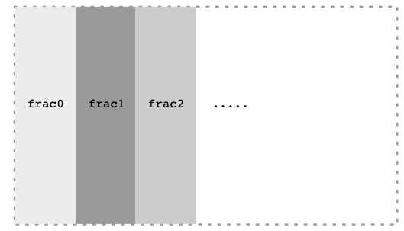
All the rectangles should be the same width. Integer ( // ) divide the canvas_width by the number of fractions to figure out how wide each rectangle should be.

Red Colour
Each data stripe will have the same green and blue values.
GREEN = 127
BLUE = 127
For each rectangle, I want to figure out a red colour based on the fraction value. I want the red value to vary so that when frac is low, red is low, and when frac is high, red is high. Specifically:
frac is 1.0 -> red is 255
frac is 0.0 -> red is 0
the formula for the amount of red in each stripe is simply the fraction * 255. The constant 255 is the MAX_RED_VALUE

Milestone 1 - Red
For testing I have the following data-test.txt file of frac values from 0 to 1.0. The first line of the file is the data set title. The second line is the number of values. The rest of the file is the floating point values.
Test Data Red to Blue
11
1.0
0.9
0.8
0.7
0.6
0.5
0.4
0.3
0.2
0.1
0.0
Try running your program with this data. You should see 11 rectangles. The far left rectangle should be quite red. The middle rectangle should be greyish. Towards the right the rectangles are an indistinct dusky blue/green colour. We'll fix them in the next milestone.
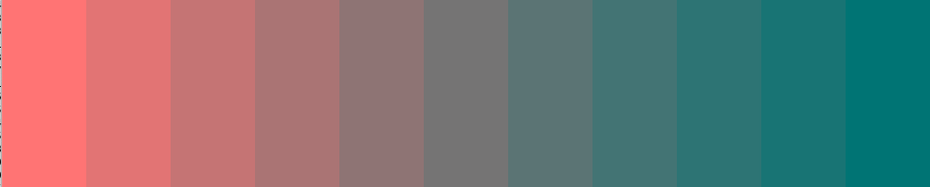
Programming aside: here we've hand-constructed this small data-test.txt file with a very clear pattern in it for testing purposes. If I jumped straight to real data with all its complexities, it would be hard to spot if the code was correct or not. This is also an advantage of text files as a data format - you can just go to your editor and type the data up.

Real Data
You've got this computed-colour visualization machinery. Let's take it for a spin. We'll take a variety of data from the real world and run it through your colour-visualization code.

Human Progress is the Trend
Here is an idea to keep in mind when looking at these data sets. Very often the news is depressing. Literally depressing. It's natural for the media to report on injustice and disasters in the world. However, the result is that gradual human progress is underreported. In reality, most measures of human wellbeing have improved hugely over recent decades. Pick a data set - child mortality, starvation, illiteracy .. they are all much improved over the last 50 years.

Child Mortality Data
data-child-mortality.txt - global percentage of children dying before the age of five. The amount of human misery in the left part of this graph is breathtaking. I trimmed the data to start at 1960 as that's when there is data for every year. Data from https://ourworldindata.org/child-mortality
We'll include this graph in the assignment handout, but the rest you should bring to life through your own code. Not many people can say they've built their own numeric-color visualization like this.

Illiteracy Data
data-illiteracy.txt - global illiteracy rate. https://data.unicef.org/topic/education/literacy/

Climate Data
data-climate.txt - this data is quite dramatic. We are a clever and resilient species, and I'm sure we will figure this out eventually. This one looks best with a width of 1200 or more.
Climate scientists measure temperature again a "0" point which is a historical global average temperature. Each year is measured as the "anomaly" from the historical average, so -1.5 C for a cold year or +1.5 C for a hot year. I scaled the climate data to fit in the -1.0 .. +1.0 format, but kept the 0 point intact, so when you see gray years, those were around the long-term average temperature, with red years above average and blue years below. This data set is from https://gmao.gsfc.nasa.gov/reanalysis/MERRA-2/
Description

